LIVE NETWORK INTRUSION
DETECTION SYSTEM
A Personal Project in Practical Network Security
Building, testing, and breaking my own intrusion detection tool
By Angelina Victor Varghese
Cybersecurity - Self-Directed Project
July 2026

1. Why I Built This
I wanted to move past tutorials and dummy datasets and actually see whether I could detect a real attack on a real network - my own. Most beginner cybersecurity projects I'd seen used pre-recorded packet captures or canned datasets, which makes it easy to get a clean result without ever touching the messy reality of live traffic. I wanted to know: could I build something that watches my actual home network in real time, and would it actually catch something if I attacked it myself?
This report documents that project end to end - including the parts that didn't work on the first try, because I think that's the more honest and more useful version of a 'project report.'

2. Problem Statement
Most networks - including home networks - are constantly exposed to scanning and probing traffic, often without the owner ever knowing. Off-the-shelf intrusion detection systems exist, but they are typically opaque: you install them and trust that they work. I wanted to understand the problem from first principles by building my own detection logic and proving, with my own evidence, that it actually catches the attack patterns it claims to.
Specifically, I set out to answer four questions:
- Can I capture real, live packets passing through my own network interface, not just simulated data?
- Can I write detection logic that correctly identifies common attack patterns - port scans, ping floods, SYN floods - from that raw traffic?
- If I deliberately attack my own machine, will my tool actually catch it, with correct evidence (source IP, timestamp, severity)?
- What does it look like when the tool gets it wrong, and can I tell the difference between a real threat and noise?

3. Why This Matters
Intrusion detection is one of the most fundamental building blocks of network security work - it's the layer that notices something is happening before anyone can respond to it. Understanding how these systems work from the inside, including their false positives and blind spots, is far more useful than knowing how to operate a commercial tool as a black box.
I also wanted hands-on experience with a problem that comes up constantly in real Security Operations Center (SOC) work: distinguishing a genuine attack from traffic that merely looks unusual. That judgment call - not just running a tool - is the actual skill SOC analysts are paid for.

4. Scope and Ground Rules
Everything in this project was tested exclusively on my own equipment: my own laptop and my own home router. I did not scan, probe, or generate traffic against any network, device, or system that isn't mine. Where I needed traffic to test against, I built a separate self-test script specifically so that all 'attack' traffic in this project was traffic I deliberately and safely generated against myself.

5. Tools and Technologies
Tool / Technology | Purpose
Npcap | Low-level packet capture driver for Windows - the same driver Wireshark uses
Python 3 / Scapy | Capturing and parsing live packets; writing the detection engine itself
Custom self-test script | Safely generating controlled port-scan and ping-flood traffic against my own devices
Windows PowerShell | Running the tool with Administrator privileges, network diagnostics (ipconfig)

6. How the Detection Engine Works
I built the tool (live_ids.py) around the idea of sliding time windows: for every packet, I track what each source IP address has been doing over the last few seconds, and raise an alert if it crosses a threshold I defined.
- Port scan: a source IP touching 15 or more distinct destination ports within a 5-second window
- Ping flood: a source IP sending 30 or more ICMP (ping) packets within a 5-second window
- SYN flood: a source IP sending 40 or more TCP SYN-only packets (half-open connections) within a 5-second window
- Traffic spike: more than 200 total packets, from any combination of sources, within a 5-second window
Each rule resets its own window independently, so the tool can catch several different things happening at once.

7. What I Actually Did - Step by Step
- Set up Npcap and Scapy, and learned the hard way that Windows requires Administrator privileges for raw packet capture - my first few attempts silently failed until I ran VS Code as admin.
- Ran the tool passively for 90 seconds with no intentional testing, just to see what normal background traffic on my network looks like to a detector like this.
- Wrote a second script (self_test.py) that deliberately generates a port scan and a ping flood, but only ever against an address I specify, to safely produce attack traffic I could test against.
- Tried testing against 127.0.0.1 (my own machine) first - and got nothing. Had to investigate why.
- Found that Npcap doesn't reliably see 'loopback' traffic (packets that never leave the network adapter), which is a genuine, documented limitation, not a bug in my code.
- Redirected my test traffic to my home router's address instead, which forced it to actually travel through my Wi-Fi adapter - and this time, the detector caught everything correctly.

8. Evidence

8.1 Confirmed Detection: Port Scan and SYN Flood
Once I pointed my self-test script at my router (192.168.0.1) while the IDS was running, it correctly caught both a port scan and a SYN flood, attributing them to the right source IP with the right severity:
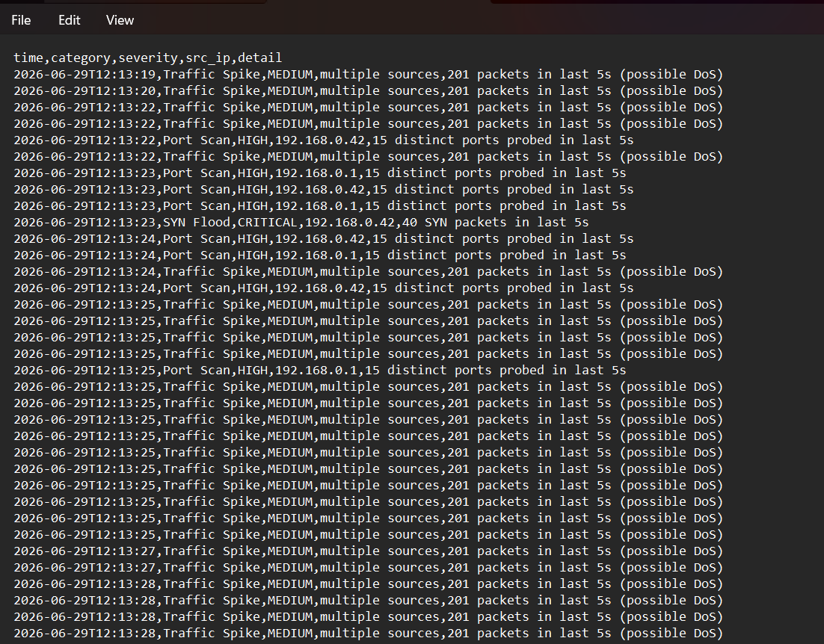
Figure 1: alerts_log.csv showing confirmed Port Scan (HIGH) and SYN Flood (CRITICAL) detections during my self-test.
This was the moment that mattered most to me in the whole project - seeing my own code correctly flag an attack I had deliberately launched, with the right IP address and the right severity level, using nothing but raw packets I captured myself.

8.2 A False Positive I Wasn't Expecting
During the very first passive run - before I'd run any test traffic at all - the tool flagged a 'Port Scan' from an IP address I didn't recognize: 52.182.143.213.
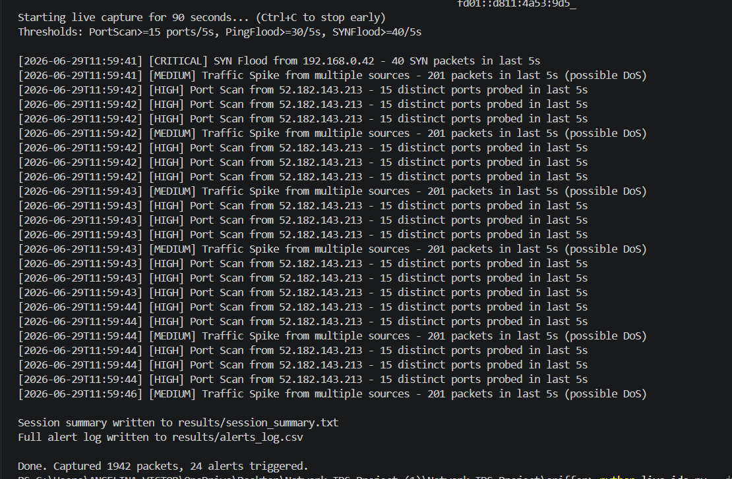
Figure 2: live terminal output showing repeated Port Scan alerts from 52.182.143.213, later identified as a Microsoft Azure address.
I looked the IP up and it belongs to Microsoft's Azure cloud infrastructure - almost certainly background traffic from Windows, OneDrive, or some other Microsoft-connected service on my own laptop, not an actual attacker. My detection logic isn't wrong, exactly: that traffic genuinely did touch many ports quickly. It just isn't malicious.
I decided to keep this in the report rather than quietly fix it and pretend it didn't happen, because this is genuinely how real detection systems behave - they flag what matches the pattern, and a human (or smarter logic) has to decide what it actually means. Recognizing a false positive instead of panicking over it is, I think, a more valuable skill to demonstrate than a project with zero unexplained alerts.

9. Problems I Ran Into (and What I Learned)

9.1 Loopback traffic is invisible to Npcap
My first instinct was to test against 127.0.0.1, since that felt like the safest possible target. It produced nothing. After some research, I learned this is a known characteristic of how Windows handles loopback traffic - it never actually reaches the network adapter that Npcap monitors. Switching my test target to my router's real IP address fixed this immediately, because that traffic has to leave the adapter to reach the router.

9.2 My 'traffic spike' rule is too sensitive
Once real test traffic was flowing, the generic traffic-spike rule fired on almost every single packet once it crossed its threshold, instead of firing once and pausing. This produced a lot of repeated, low-value log lines. I've left this as a known issue rather than quietly hiding it - the fix is straightforward (add a cooldown after each alert), but I'd rather be upfront that I noticed the noise and understand why it happened than present a polished log that hides it.

10. Results Summary
Run | Packets Captured | Alerts Raised
Passive baseline (no testing) | 1,942 | 24 (incl. 1 false positive)
Self-test against my router | 8,888 | 53 (incl. confirmed Port Scan + SYN Flood)

11. What I'd Improve Next
- Add a cooldown period to the traffic-spike rule so it alerts once per burst instead of repeating on every packet.
- Add a basic IP-reputation or cloud-provider lookup so traffic from known providers like Microsoft/Azure/AWS doesn't trigger the same alert as an unknown IP.
- Capture a longer baseline (hours, not minutes) to set thresholds based on my actual network's normal behaviour instead of guessed defaults.
- Look into Npcap's loopback adapter option so I can properly test self-addressed traffic without needing to route through the router.

12. Conclusion
This project gave me something tutorials hadn't: a working tool that watches real traffic on a network I actually use, and proof - in my own logs, from my own machine - that it can tell the difference between normal noise, a misleading false positive, and a genuine, deliberate attack.
The most valuable part wasn't the parts that worked on the first try - it was figuring out why my own machine couldn't 'see' its own loopback traffic, and noticing and explaining a false positive instead of ignoring it. That troubleshooting process is, as far as I can tell, much closer to what real security work actually looks like than a project where everything goes right the first time.

13. References
- Npcap - https://npcap.com/
- Scapy Documentation - https://scapy.readthedocs.io/
- OWASP - Denial of Service Cheat Sheet - https://owasp.org/www-community/attacks/Denial_of_Service
- SANS Institute - Intrusion Detection FAQ - https://www.sans.org/

